|  |  |
| --- | --- |
| **Name:** | Bodhisatya Ghosh |
| **Branch:** | CSE – Data Science |
| **Batch:** | B |
| **Course:** | Soft Computing |
| **Experiment no:** | 10 |

**Aim:** To implement swarm intelligence for a given problem.

**Theory:** In general, swarm intelligence algorithms are nature-inspired algorithms developed based on the interactions between living organisms such as flocks of birds, ants, and fish. These algorithms help in the enhancement of fitness functions in combinatorial and numerical optimization problems by discovering different combinations of values. Particle swarm optimization (PSO) was proposed in Kennedy and Eberhart (1995). It is one of the popular bio-inspired stochastic global search algorithms which models the social behavior of a flock of birds. Basically, PSO comprises a set of population (swarm) that is “S” number of particles. Every particle represents a solution for every candidate. Particles discover “n” dimensional search space to obtain a global solution, where n represents the number of parameters considered for optimization.

**Application: Image filtering using PSO**

The application of Particle Swarm Optimization (PSO) for image filtering provides a versatile tool in computer vision and image processing. By dynamically optimizing filter kernels, this program addresses diverse applications, including image denoising, smoothing, edge detection, and feature enhancement. The optimized filters contribute to improved image quality, making the technique valuable in medical imaging, enhanced visualization, and preprocessing for machine learning tasks. Additionally, the customization of image effects enables creative applications in photography and artistic image editing. With potential applications in content-based image retrieval, video processing, and various domains, PSO-based image filtering offers adaptive and efficient solutions for enhancing and analyzing visual data.

**Program:**

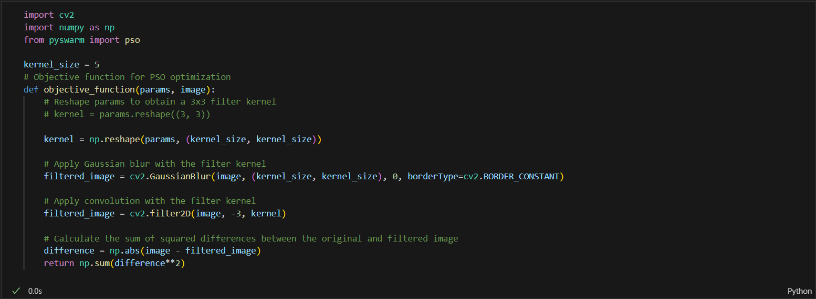

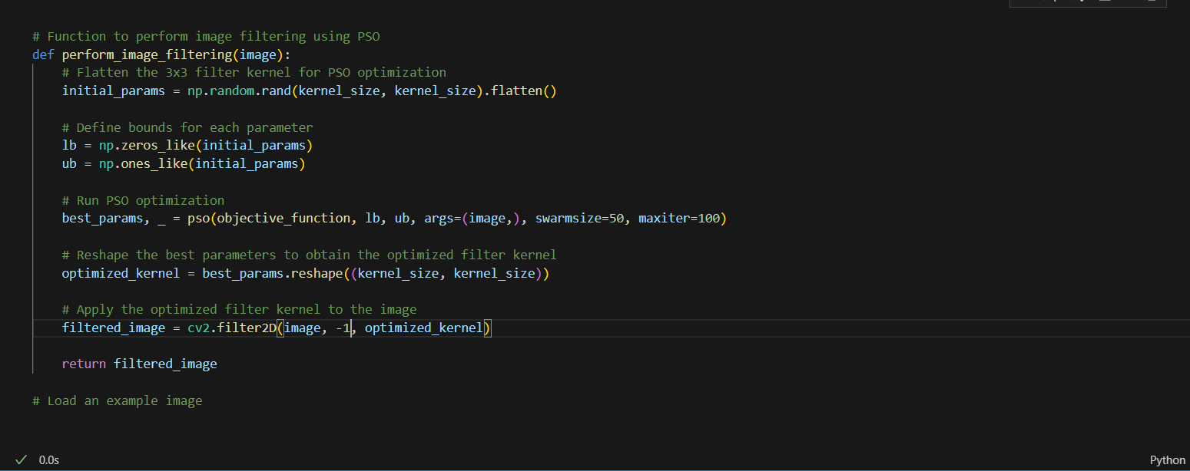

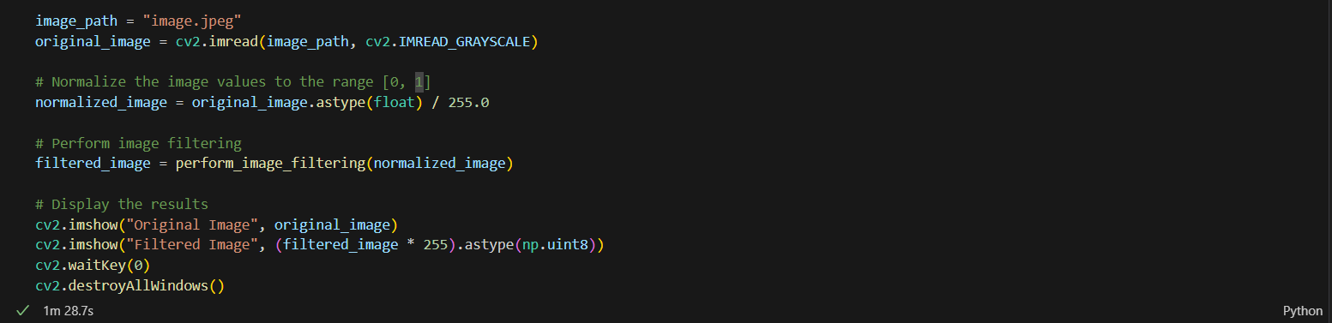

**Results:**





**CONCLUSION: -** From this experiment I learnt about genetic algorithm and how to implement it in basic function optimization problem.